The Spiral Model is one of the most important SDLC model. The Spiral Model is a combination of the waterfall model and the iterative model. It provides support for Risk Handling.
The Spiral Model was first proposed by Barry Boehm.

What is the Spiral Model?
The Spiral Model is a Software Development Life Cycle (SDLC) model that provides a systematic and iterative approach to software development. In its diagrammatic representation, looks like a spiral with many loops. The exact number of loops of the spiral is unknown and can vary from project to project. Each loop of the spiral is called a phase of the software development process.
Some Key Points regarding the Stages of a Spiral Model:
- The exact number of phases needed to develop the product can be varied by the project manager depending upon the project risks.
- As the project manager dynamically determines the number of phases, the project manager has an important role in developing a product using the spiral model.
- It is based on the idea of a spiral, with each iteration of the spiral representing a complete software development cycle, from requirements gathering and analysis to design, implementation, testing, and maintenance.

Phases of the Spiral Model
The Spiral Model is a risk-driven model, meaning that the focus is on managing risk through multiple iterations of the software development process. Each phase of the Spiral Model is divided into four Quadrants:
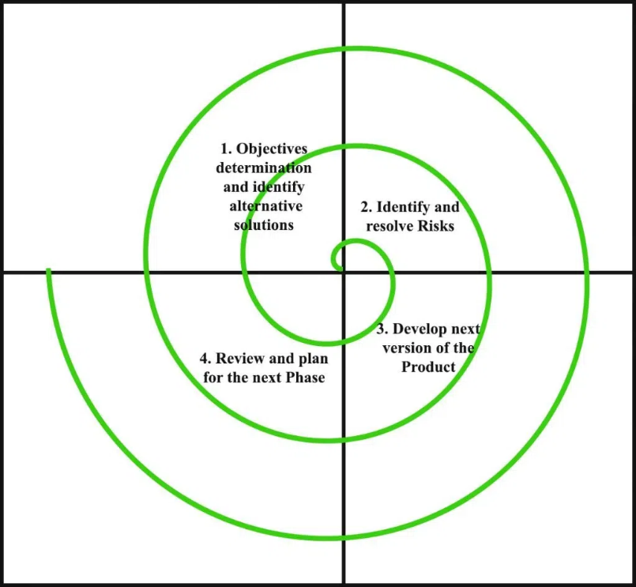

1. Objectives Defined
In first phase of the spiral model we clarify what the project aims to achieve, including functional and non-functional requirements.
Requirements are gathered from the customers and the objectives are identified, elaborated, and analyzed at the start of every phase. Then alternative solutions possible for the phase are proposed in this quadrant.
2. Risk Analysis and Resolving
In the risk analysis phase, the risks associated with the project are identified and evaluated.
During the second quadrant, all the possible solutions are evaluated to select the best possible solution. Then the risks associated with that solution are identified and the risks are resolved using the best possible strategy. At the end of this quadrant, the Prototype is built for the best possible solution.
3. Develop the next version of the Product
During the third quadrant, the identified features are developed and verified through testing. At the end of the third quadrant, the next version of the software is available.
In the evaluation phase, the software is evaluated to determine if it meets the customer's requirements and if it is of high quality.
4. Review and plan for the next Phase
In the fourth quadrant, the Customers evaluate the so-far developed version of the software. In the end, planning for the next phase is started.
The next iteration of the spiral begins with a new planning phase, based on the results of the evaluation.
The Spiral Model is often used for complex and large software development projects, as it allows for a more flexible and adaptable approach to Software development. It is also well-suited to projects with significant uncertainty or high levels of risk.
The Radius of the spiral at any point represents the expenses (cost) of the project so far, and the angular dimension represents the progress made so far in the current phase.
Risk Handling in Spiral Model
A risk is any adverse situation that might affect the successful completion of a software project. The most important feature of the spiral model is handling these unknown risks after the project has started. Such risk resolutions are easier done by developing a prototype.
- The spiral model supports coping with risks by providing the scope to build a prototype at every phase of software development.
- The Prototyping Model also supports risk handling, but the risks must be identified completely before the start of the development work of the project.
- But in real life, project risk may occur after the development work starts, in that case, we cannot use the Prototyping Model.
- In each phase of the Spiral Model, the features of the product dated and analyzed, and the risks at that point in time are identified and are resolved through prototyping.
- Thus, this model is much more flexible compared to other SDLC models.
Why Spiral Model is called Meta Model?
The Spiral model is called a Meta-Model because it subsumes all the other SDLC models. For example, a single loop spiral actually represents the Iterative Waterfall Model.
- The spiral model incorporates the stepwise approach of the Classical Waterfall Model.
- The spiral model uses the approach of the Prototyping Model by building a prototype at the start of each phase as a risk-handling technique.
- Also, the spiral model can be considered as supporting the Evolutionary model - the iterations along the spiral can be considered as evolutionary levels through which the complete system is built.
Example of Spiral Model
Here we can take a Real world example of the Spiral Model.
Real-Life Example of Spiral Model: Developing an E-Commerce Website
1. First Spiral - Planning and Requirements:
In this first phase, the team gathers the basic requirements for the e-commerce website, like product listings, shopping carts, and payment options. They also identify potential risks, like security issues or scalability concerns.
To get started, they build a simple prototype, like a homepage with a basic product catalog, to see how users interact with it and spot any initial design problems.
2. Second Spiral - Risk Analysis and Refining the Design
After getting feedback from the first prototype, the team moves to the next phase. They add more features and address the problems that were found earlier.
This includes verifying secure payment processing and testing how the site handles more users. They also add a basic shopping cart and user registration system, and they run tests with dummy transactions to make sure everything is secure.
3. Third Spiral - Detailed Implementation
With more feedback in hand, the team adds advanced features, like order tracking, customer reviews, and a search function. They also revisit any remaining risks, especially around scalability making sure the website can handle a growing number of users.
During this phase, the team tests the site to verify it can handle large orders, especially during busy times like sales or holidays.
4. Final Spiral - Full Deployment
In the last phase, the website is fully implemented, tested properly, and then launched to the public. Any remaining risks, like potential crashes or user feedback issues, are closely monitored and dealt with.
This example shows how the Spiral Model allows for continuous improvement, with feedback and risk assessment at each step to make sure the final product is solid and reliable.
Advantages of the Spiral Model
Below are some advantages of the Spiral Model.
- Risk Handling: The projects with many unknown risks that occur as the development proceeds, in that case, Spiral Model is the best development model to follow due to the risk analysis and risk handling at every phase.
- Good for large projects: It is recommended to use the Spiral Model in large and complex projects.
- Flexibility in Requirements: Change requests in the Requirements at a later phase can be incorporated accurately by using this model.
- Customer Satisfaction: Customers can see the development of the product at the early phase of the software development and thus, they habituated with the system by using it before completion of the total product.
- Iterative and Incremental Approach: The Spiral Model provides an iterative and incremental approach to software development, allowing for flexibility and adaptability in response to changing requirements or unexpected events.
- Emphasis on Risk Management: The Spiral Model places a strong emphasis on risk management, which helps to minimize the impact of uncertainty and risk on the software development process.
- Improved Communication: The Spiral Model provides for regular evaluations and reviews, which can improve communication between the customer and the development team.
- Improved Quality: The Spiral Model allows for multiple iterations of the software development process, which can result in improved software quality and reliability.
Disadvantages of the Spiral Model
Below are some main disadvantages of the spiral model.
- Complex: The Spiral Model is much more complex than other SDLC models.
- Expensive: Spiral Model is not suitable for small projects as it is expensive.
- Too much dependability on Risk Analysis: The successful completion of the project is very much dependent on Risk Analysis. Without very highly experienced experts, it is going to be a failure to develop a project using this model.
- Difficulty in time management: As the number of phases is unknown at the start of the project, time estimation is very difficult.
- Complexity: The Spiral Model can be complex, as it involves multiple iterations of the software development process.
- Time-Consuming: The Spiral Model can be time-consuming, as it requires multiple evaluations and reviews.
- Resource Intensive: The Spiral Model can be resource-intensive, as it requires a significant investment in planning, risk analysis, and evaluations.
The most serious issue we face in the cascade model is that taking a long length to finish the item, and the product became obsolete. To tackle this issue, we have another methodology, which is known as the Winding model or spiral model. The winding model is otherwise called the cyclic model.
When To Use the Spiral Model?
Here are the reasons where the Spiral Model is used:
- When a project is vast in Software Engineering, a spiral model is utilized.
- A spiral approach is utilized when frequent releases are necessary.
- When it is appropriate to create a prototype
- When evaluating risks and costs is crucial
- The spiral approach is beneficial for projects with moderate to high risk.
- The SDLC's spiral model is helpful when requirements are complicated and ambiguous.
- If modifications are possible at any moment
- When committing to a long-term project is impractical owing to shifting economic priorities.
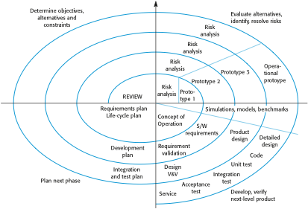

Case Study Example: Online Banking System
📌 Problem Statement
A bank wants to develop a secure online banking application that allows customers to:
- View account details
- Transfer funds
- Pay bills
- Access transaction history
- Use mobile and web versions
The project involves high risk due to security, compliance, and scalability requirements.
Application of Spiral Model
🔄 First Spiral (Concept Development)
- Planning: Collect basic requirements (account login, fund transfer).
- Risk Analysis: Identify major risks – e.g., hacking, data leakage, unauthorized access.
- Engineering: Develop a prototype of login and dashboard.
- Evaluation: Show prototype to stakeholders for feedback.

🔄 Second Spiral (Refinement & Design)
- Planning: Expand requirements (bill payments, transaction history).
- Risk Analysis: Evaluate risks in secure payment gateways and database performance.
- Engineering: Design system architecture (multi-tier), database schema.
- Evaluation: Review design with stakeholders, test security models.

🔄 Third Spiral (Implementation)
- Planning: Prepare for coding modules (fund transfer, bill payment).
- Risk Analysis: Risk of integration failure with existing banking systems.
- Engineering: Develop core modules, encryption system, and authentication (2FA).
- Evaluation: Test modules with pilot users, gather feedback.

🔄 Fourth Spiral (Testing & Deployment)
- Planning: Plan system testing and gradual deployment.
- Risk Analysis: Identify risks like system downtime or performance issues.
- Engineering: Perform rigorous testing (unit, integration, security, load).
- Evaluation: Deploy for real users, monitor performance, fix issues.
Spiral Cycle | Planning | Risk Analysis | Engineering / Development | Evaluation & Review
1st Spiral (Concept Development) | Gather basic requirements (login, account dashboard, fund transfer). | Risks: hacking, unauthorized access, data leakage. | Develop prototype for login screen and account summary. | Stakeholders review prototype; feedback for security & usability.
2nd Spiral (Design) | Expand requirements: bill payments, transaction history, mobile support. | Risks: secure payment gateway, database performance issues. | Design multi-tier architecture, database schema, and system modules. | Stakeholders review design; test encryption models.
3rd Spiral (Implementation) | Plan coding modules for fund transfer, bill payments, transaction history. | Risks: integration failure with existing core banking system, encryption errors. | Develop modules, implement authentication (2FA), and encryption. | Pilot testing with small group of users; collect feedback.
4th Spiral (Testing & Deployment) | Plan for system testing and rollout. | Risks: downtime during deployment, performance bottlenecks. | Conduct unit, integration, load, and security testing. | Deploy to real users in phases; monitor system and apply fixes.

